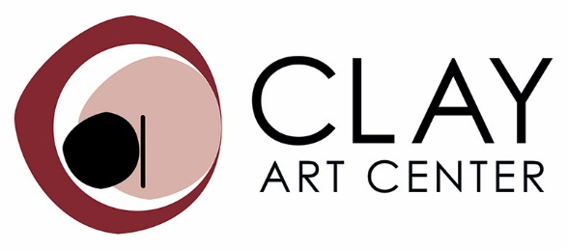
40 Beech Street, Port Chester, NY 10573
www.clayartcenter.org

FOR IMMEDIATE RELEASE:

Media Contact: Regina Farrell-Fagan, Exhibitions & Marketing Director
communications@clayartcenter.org, regina@clayartcenter.org

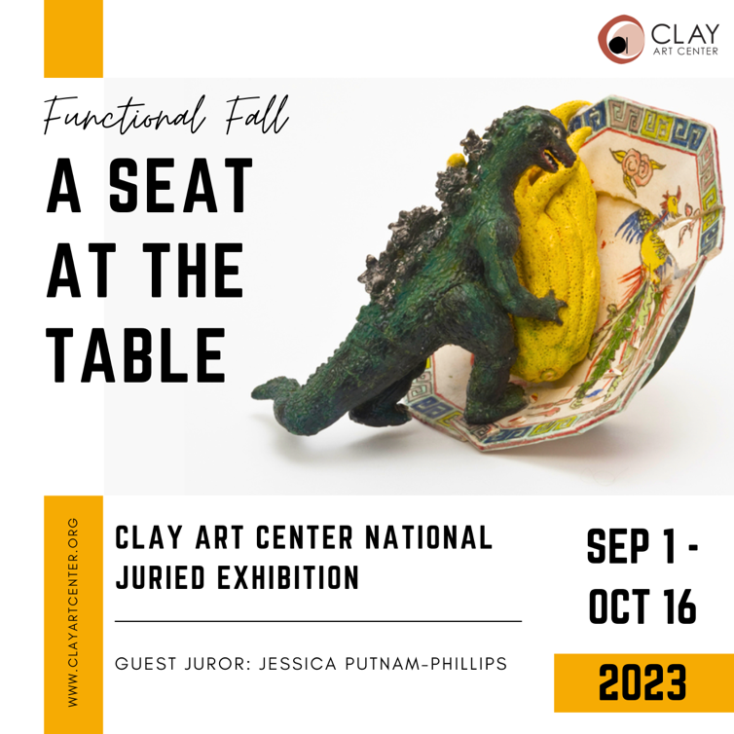

Clay Art Center presents
Functional Fall: A Seat at The Table

A Call for Entry Exhibition Guest Juried by Jessica Putnam-Phillips

In the Gallery & Online
September 1 – October 16, 2023

Opening Reception: Saturday, September 9, 6pm – 8pm

Linda Fitz Gibbon "Battle of The Sexes", Hand built Ceramic 10.5" x 8.25" x 8.25"

Clay Art Center is proud to present our First Annual Functional Fall Exhibition “A Seat at The Table”. This National Call For Entry Exhibition is guest juried by Jessica Putnam Phillips, and brings everyone to the table through ceramics that serve, featuring work from artists at all stages of their careers throughout the US.
“This exhibition of functional ceramics focuses on the concept of “service” in tableware. Encompassing a wide range of ceramic styles from evocative shapes made to serve functionally, to conceptual and narrative work that explores the ideas of serving beyond the traditional role as a vessel for a meal, these objects set the table for a dialog between maker and viewer. This exhibition aims to present ceramics that bring people together for discourse and sustenance for the mind, body, and soul.” Jessica Putnam-Phillips

Participating Artists include: Vasfiie Abderafi, Madeleine Althoff, Rana Amirtahmasebi, Marion Angelica, Ian Bassett, Jacob Bassett, Maxine Bell, Michael Blair, Yael Braha, Angel Brame, Asta Bubliene, Jeanne Carreau, Jess Cropper-Alt, Orit Daly, Diane DiMauro, Beverly Fetterman, Vicki Finkel, Linda Fitz Gibbon, Richa Gupta, Ian Hazard-Bill, Robin Heschel, Amy Henson, Emma Herz, Lindsay Hitch, Jeremiah Ibarra, Deborah Kaplan, Karina Larsen, Stacy Larson, Beth Lee, Jamie Lee, Sheetal Mehta, Laura Montoya, Kay Petronio, Katie Reeves, Kristyn Rohrer, Mark Rossier, Jocelyn Russell, Shana Salaff, Amy Schnitzer, Amie Sell, Elizabeth Tolson, Suruchi Tripathi, Ann Wetzel, GH Wood
Please join us for an Opening Reception on Saturday, September 9th, 6pm - 8pm
Guest Juror Jessica Putnam-Phillips will attend the reception, and award juror prizes.
Jessica Putnam-Phillips will also present a hands-on workshop on Surface Decoration and Embellishment on Saturday, September 9 from 10am – 4pm. Students will work on a variety of techniques to explore surface qualities and finishes in clay, resulting in a sampler wall quilt that can be used decoratively as well as for reference.

Guest Juror Jessica Putnam-Phillips is a ceramic artist, USAF veteran, and educator. She received her MFA from the Art Institute of Boston and her BA from UNC-Wilmington. She was a resident artist at the Saratoga Clay Art Center and at AIR Vallauris, France. She actively promotes ceramic art and education and is the founder of ClayShare, an online school for ceramic learning. Jessica’s work has been in national and international exhibitions, most notably at the Museum of Craft and Design, the Craft and Folk-Art Museum, the American Museum of Ceramic Art and the Veterans’ Art Museum. She is a past winner of the Zanesville Prize and was named a potter to watch by C-File. She has been a presenter at NCECA, ClayCon West and the Veterans Triennale and Art Summit. When not traveling for workshops, presentations and residencies Jessica can be found in her Vermont studio developing and filming classes for ClayShare and creating new ceramic work.

View the exhibition online at www.clayartcenter.org

Clay Art Center is a nationally recognized non-profit center for the advancement and practice of ceramic arts offering exhibitions, clay classes for adults and children, studio spaces for clay artists and outreach programs in the community. It is located in the heart of Port Chester at 40 Beech Street, Port Chester, NY 10573. Join Clay Art Center for virtual & in-person classes, exhibitions and shop at www.clayartcenter.org.

